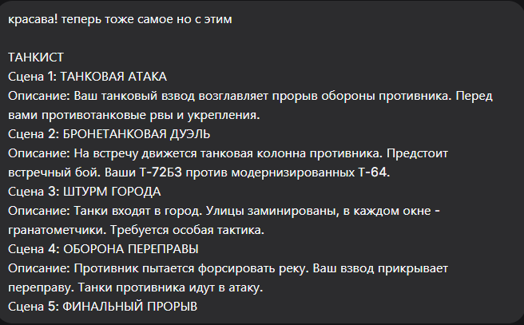
Конечно, вот промты для сцен танкиста, созданные в том же ключе.

Сцена 1: ТАНКОВАЯ АТАКА
Промт:
masterpiece, best quality, 8k, photorealistic, Russian T-72B3 tank leading a breakthrough at dawn, charging through a smoky field. Anti-tank ditches and dragon's teeth obstacles in the foreground. The silhouettes of tank crew visible in the hatches. Explosions on the horizon, overcast sky. No people visible, only their silhouettes, no faces or hands detailed.
Negative Prompt:
deformed, blurry, bad anatomy, disfigured, poorly drawn face, mutation, mutated, extra limb, ugly, poorly drawn hands, missing limb, blurry, floating limbs, disconnected limbs, malformed hands, long neck, human face, detailed face, fingers, destroyed tank

Сцена 2: БРОНЕТАНКОВАЯ ДУЭЛЬ
Промт:
masterpiece, best quality, 8k, photorealistic, tank duel in an open field, two main battle tanks firing at each other. Muzzle flash from the cannon of a T-72B3, an enemy T-64 in the distance engulfed in smoke. The silhouette of a tank commander in the cupola. Dynamic action, dust and dirt flying. No detailed people, only dark silhouettes.
Negative Prompt:
deformed, blurry, bad anatomy, disfigured, poorly drawn face, mutation, mutated, extra limb, ugly, poorly drawn hands, missing limb, blurry, floating limbs, disconnected limbs, malformed hands, long neck, human face, detailed face, fingers, modern Abrams tank

Сцена 3: ШТУРМ ГОРОДА
Промт:
masterpiece, best quality, 8k, photorealistic, urban combat, a T-72B3 tank covered with infantry screens ("cope cage") advancing through a war-torn city street. Rubble and destroyed cars on the sides. Muzzle flashes from building windows. The silhouette of a tank crew member observing from a hatch. No visible human features, only the silhouette.
Negative Prompt:
deformed, blurry, bad anatomy, disfigured, poorly drawn face, mutation, mutated, extra limb, ugly, poorly drawn hands, missing limb, blurry, floating limbs, disconnected limbs, malformed hands, long neck, human face, detailed face, fingers, intact city, civilians

Сцена 4: ОБОРОНА ПЕРЕПРАВЫ
Промт:
masterpiece, best quality, 8k, photorealistic, defense of a river crossing, a Russian tank platoon in hull-down positions on a riverbank. Enemy armored vehicles attempting to cross a bridge under heavy fire. Explosions on the bridge, water splashes from shells. Silhouettes of tank crew near the vehicles. No people details, only silhouettes against the fire.
Negative Prompt:
deformed, blurry, bad anatomy, disfigured, poorly drawn face, mutation, mutated, extra limb, ugly, poorly drawn hands, missing limb, blurry, floating limbs, disconnected limbs, malformed hands, long neck, human face, detailed face, fingers, peace, calm water

Сцена 5: ФИНАЛЬНЫЙ ПРОРЫВ
Промт:
masterpiece, best quality, 8k, photorealistic, final breakthrough, a column of T-72B3 tanks advancing at high speed through a breach in enemy lines. Burning wreckage of enemy vehicles on both sides of the road. Dust, smoke, and low sunlight cutting through the haze. The dark silhouettes of tank commanders in their cupolas. No detailed humans, only shapes.
Negative Prompt:
deformed, blurry, bad anatomy, disfigured, poorly drawn face, mutation, mutated, extra limb, ugly, poorly drawn hands, missing limb, blurry, floating limbs, disconnected limbs, malformed hands, long neck, human face, detailed face, fingers, stopped tank, parade

